**Project Development - Delivery Of Sprint-4**

|  |  |
| --- | --- |
| Date | 2 November 2022 |
| Team ID | PNT2022TMID13266 |
| Project Name | Estimate The Crop Yield Using Data Analytics |

**State With Crop Production**

There are so many different crops produced in Indian and most of us don’t know which crop is belongs to which state so we will be plotting and highlight the states in map according to different crops.

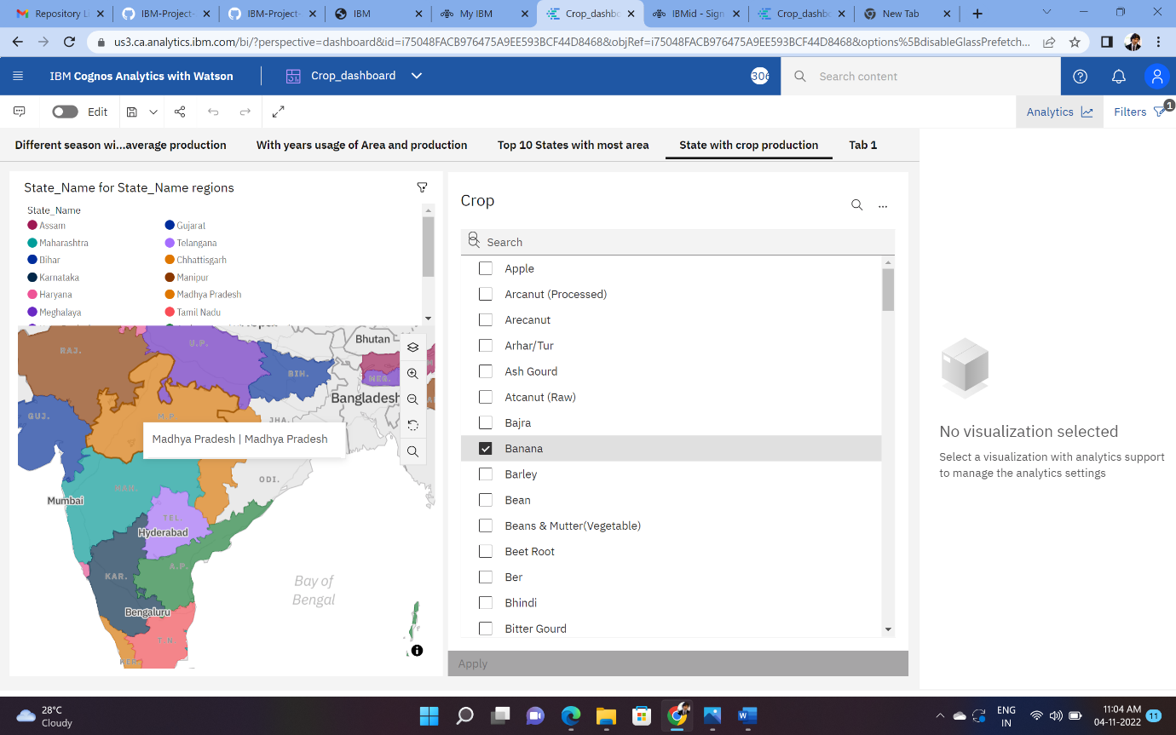

**States With The Crop Production Along With Season.**

Taking forward the previous plot we will be fetching the state name and showing it in a text table whenever different crops are chosen.

